Linear Prediction in MATLAB

Signal is from ELECTENG 733 Lab 2. “Carl leaps into a jeep” male, NZ English.

# MATLAB Code

clear;

% Audio file to be analysed

filename = 'vowel.wav';

% Linear prediction order

p = 3;

% Read file

[s,Fs] = audioread(filename);

n = 0:size(s)-1;

% Perform LPC analysis, determine estimated signal and error

a = lpc(s,p);

s_est = filter([0,-a(2:end)],1,s);

e = s-s_est;

% Zoom in on the signal and error

n1 = 501:800;

s1 = s(n1);

e1 = e(n1);

% Plot of signals

figure(1);

plot(n,s,n,s_est);

legend('orginal','estimated');

xlabel('n')

ylabel('s[n]')

title('Original signal and Estimated signal');

% Plot of error signal

figure(2);

plot(n,e);

xlabel('n')

ylabel('e[n]')

title('Error');

% Plot of zoomed in signal

figure(3);

subplot(2,1,1)

stem(n1,s1);

xlabel('n')

ylabel('s[n]')

title('Original Signal')

subplot(2,1,2)

stem(n1, e1.^2);

xlabel('n')

ylabel('e[n]^2')

title('Error squared')

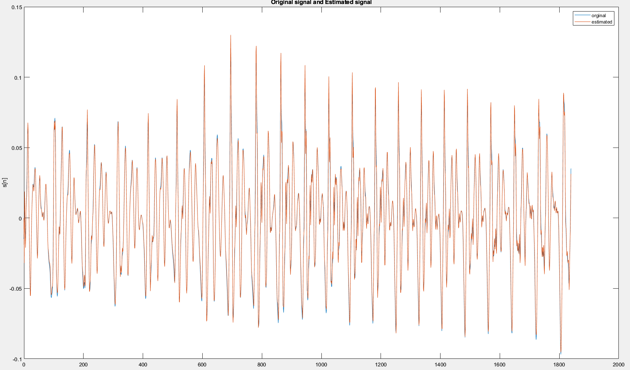

*A zoomed in vowel sound /a/ in “Carl” $s[n]$ and the prediction $\hat{s}[n]$. Prediction order is 3.*

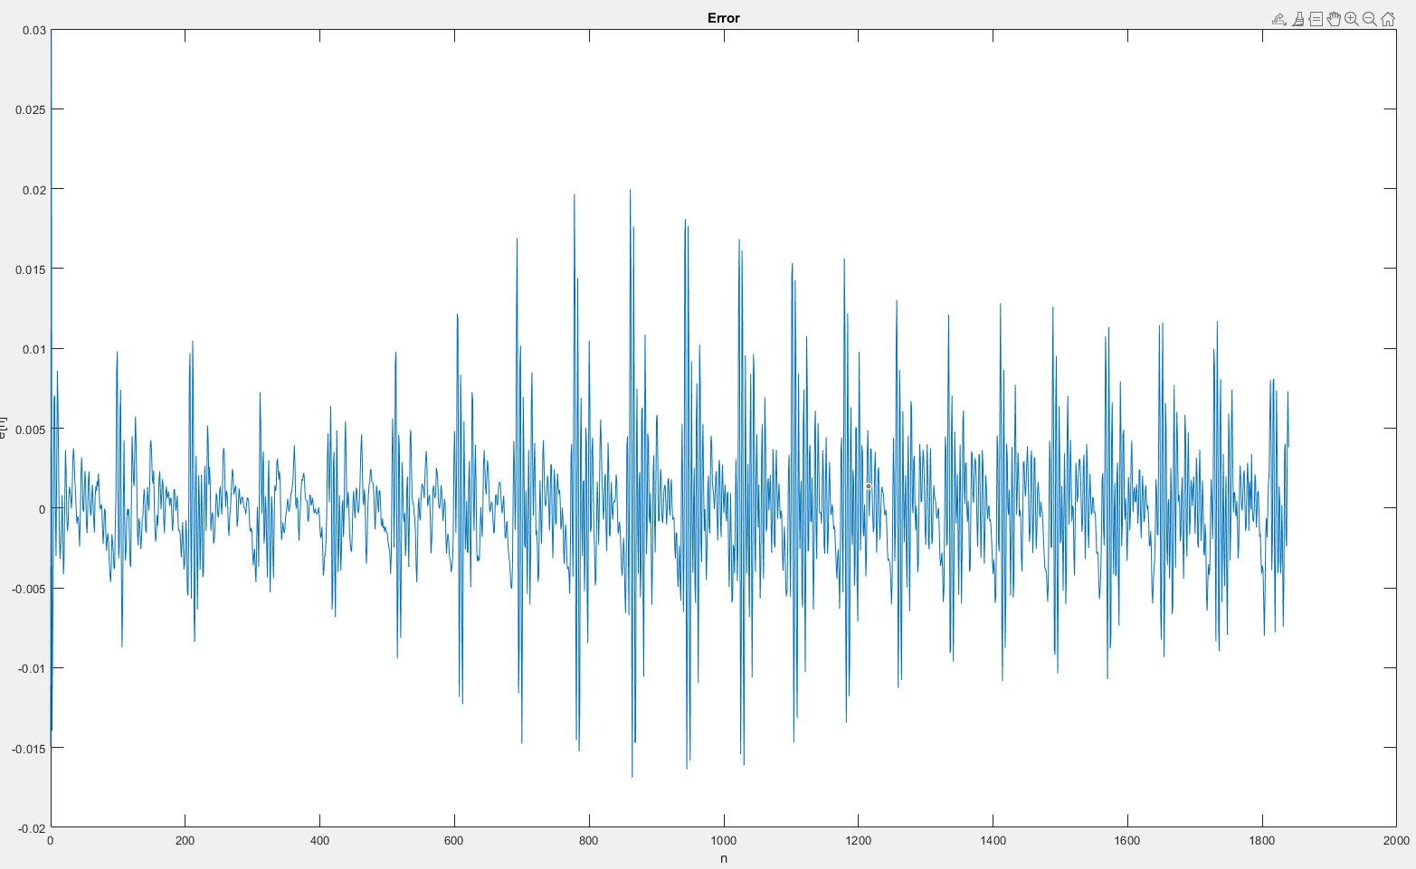

*Error signal $e\left[n\right]=s\left[n\right]-\hat{s}[n]$.*

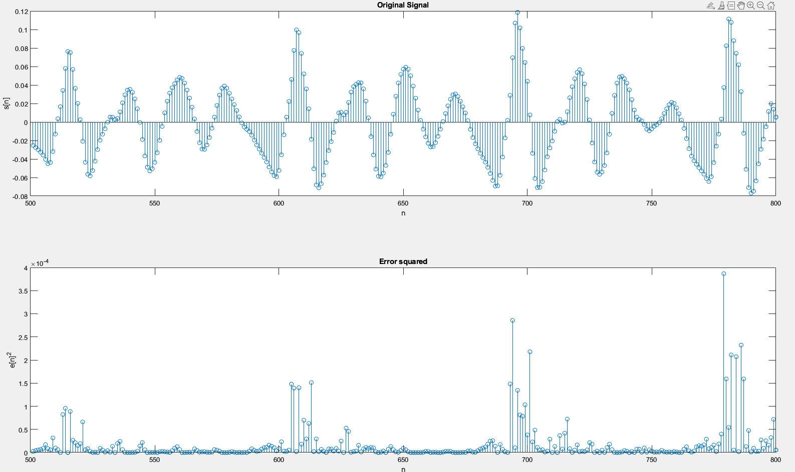

*Stem plot of a few periods and the corresponding error. Peaks of the error line up with peaks in the signal.*

# Long Term Prediction

The following MATLAB code implements the long term prediction,

% Long term prediction order

Q = 2;

% Pitch estimation

f0 = pitch(e, Fs, Method='LHS');

N0=Fs./f0;

N0_avg = round(mean(N0));

% Shift error to the right by N0, e(1)=e_shift(N0+1)

e_shift = zeros(size(e,1)+N0_avg,1);

e_shift(N0_avg+1:end) = e(1:end);

n2 = 0:size(e_shift)-1;

% Perform a long term LPC prediction. LPC on e is predicting e_shift. what

% about b0 coefficeint?

b1 = lpc(e, Q);

e_shift_est = filter([0,-b1(2:end)],1,e_shift);

q = e_shift-e_shift_est;

e_shift is the error signal, shifted to the right by one fundamental pitch period N0_avg (zeros from index 1 – N0_avg. Linear prediction is performed on the error signal e which is used to predict e_shift. This is equivalent to obtaining $\hat{e}[n]$ using the samples $e[n-T-Q]$ to $e[n-T-1]$, i.e.

$$\hat{e}\left[n\right]=\sum_{k=1}^{Q}{b_{k}e[n-T-k]}.$$

In the text, the prediction uses samples $e[n-T-Q]$ to $e[n-T+Q]$,

$$\hat{e}\left[n\right]=\sum_{k=-Q}^{Q}{b_{k}e\left[n-T-k\right].}$$

Not sure how to implement this. The wideband noise component is calculated as

$$q\left[n\right]=e\left[n\right]-\hat{e}\left[n\right].$$

There is some phase delay, which is expected since I just used the average pitch period.

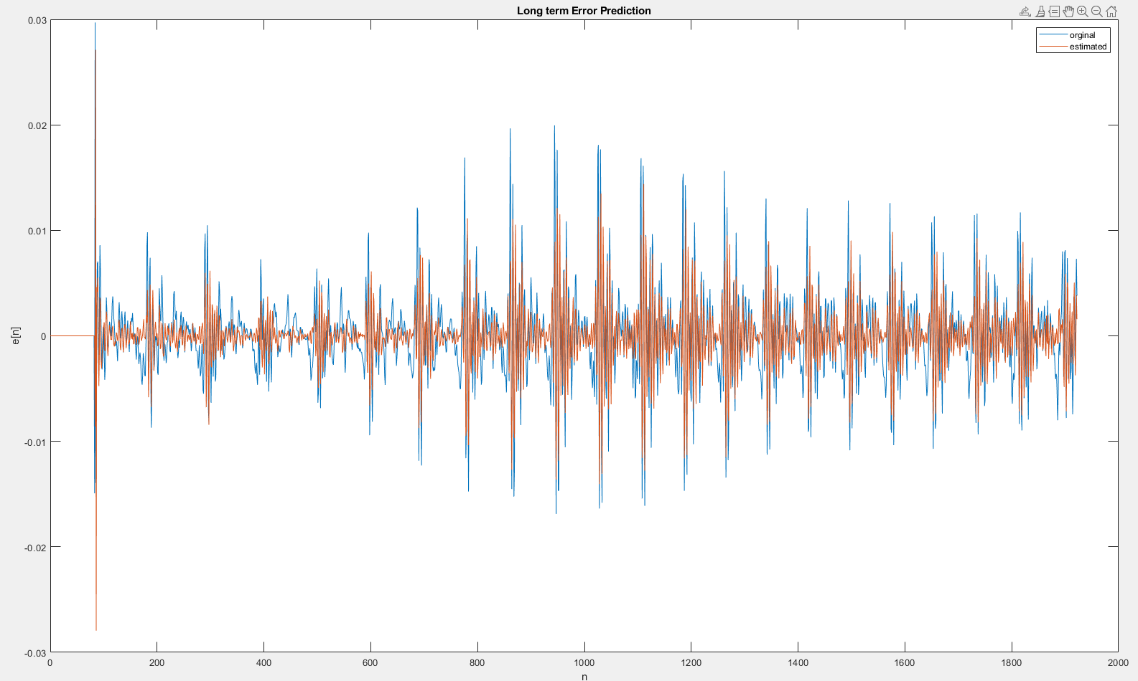

*Error and Predicted Error*

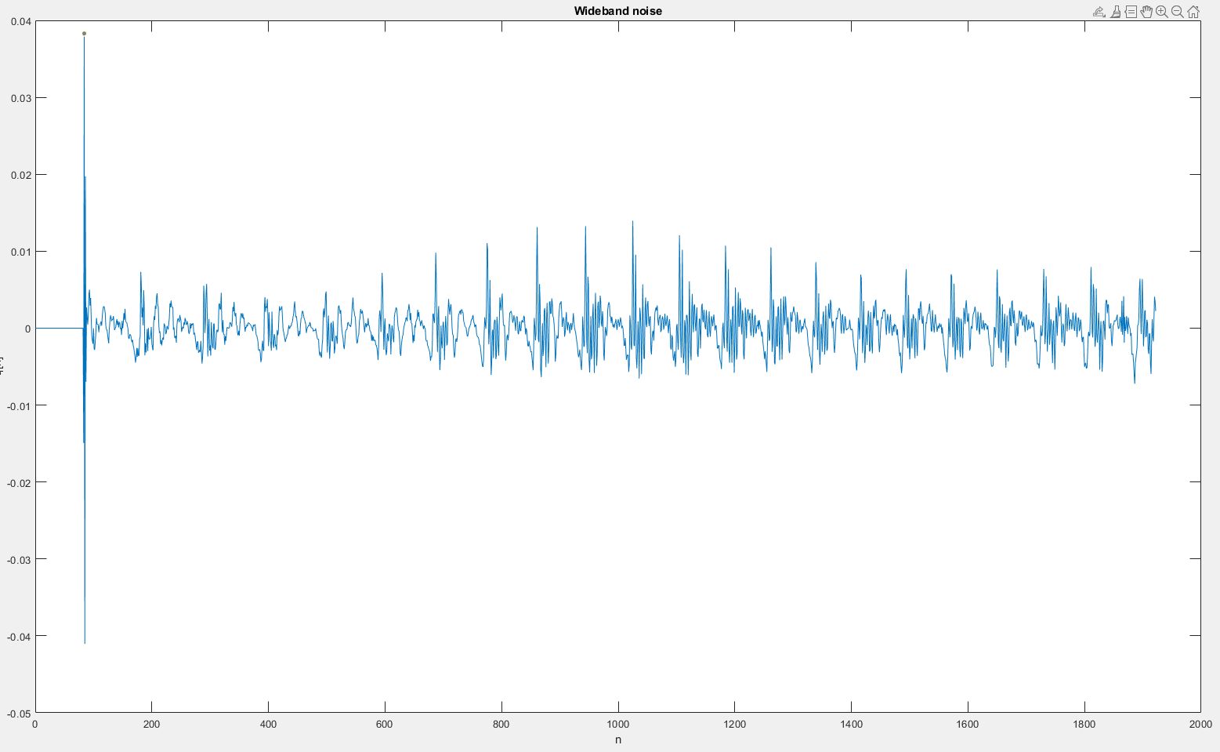

*Wideband noise component*